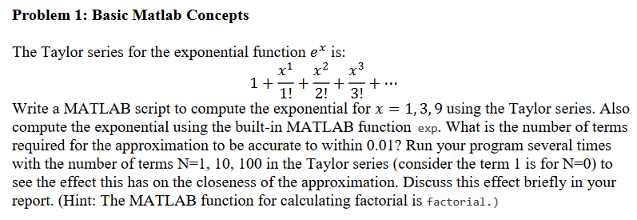

My MatLab script to compute the Taylor series:

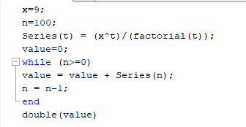

Where I changed the values of x and n.

For x=1

N=1, value = 2  
N=10, value = 2.7183  
N=100, value = 2.7183

For x=3

N=1, value = 4  
N=10, value = 20.0797  
N=100, value = 20.0855

For x=9

N=1, value = 10  
N=10, value = 5.7207e3  
N=100, value = 8.1031e3

Using the exp(x) function to confirm these findings:

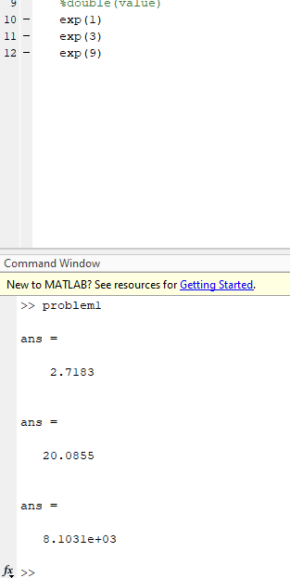

Shows that increasing N increases precision. This is due to the way Taylor series works in that the infinite summation:

$$\sum_{n=0}^{∞}{\frac{x^{n}}{n!}}$$

Where for any n, the maximum error is the value of the equation when n=n+1

Problem 2:

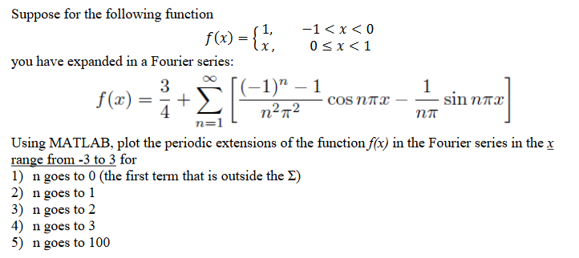

1. Plotting for n=0  
   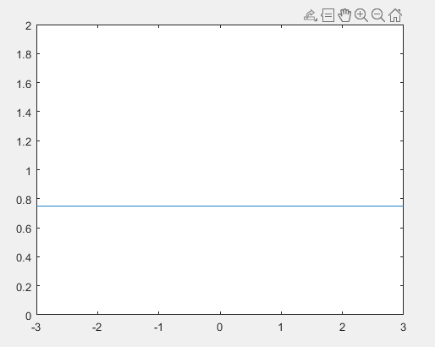
2. Plotting for n=0 and n=1  
   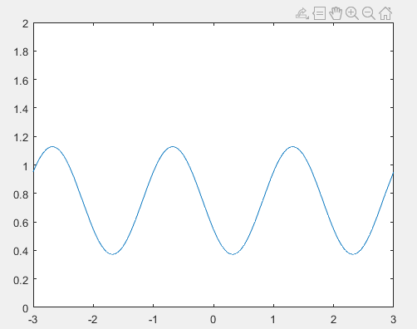
3. Plotting for n=1 to n=2  
   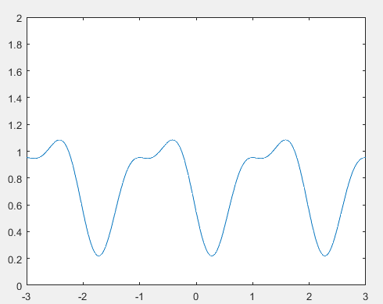
4. Plotting for n=0 to n=3  
   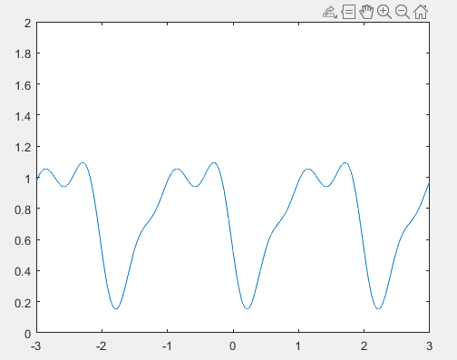
5. Plotting for n=0 to n=100  
   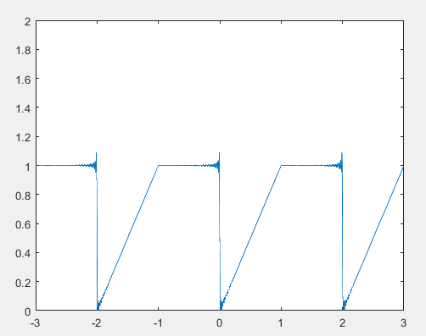

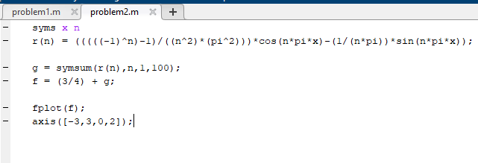

Figure 1. Code used to plot the summation for different bounds of N.